BHS STAGE 4 KNOWLEDGE & CARE COURSE
ONE WEEK HORSE CARE & MANAGEMENT COURSES
ONE WEEK HORSE COURSES AT
Thurleigh Equestrian Club
THURLEIGH EQUESTIAN CENTRE

We are very pleased to be offering two levels of one week programmes of horse activity during the summer for anyone aged 12 and over who would like to spend a week (or two) finding out more about horses. We are a British Horse Society Approved Centre and our staff are CRB/DBS checked, qualified riding instructors with experience of delivering BHS Horse Care and Management training in equine colleges and riding centres.

We have an indoor stable barn, training room and riding school so can deal with all weather conditions and keep everyone warm and dry!

Running from Monday to Friday, from 9am until 4pm, (registration is available from 8.45am) you can either join us for the full week or just book for individual days on either course. Sadly spaces will be limited to a maximum of 8 people per day/course, and we must give priority to those booking for the full week, so please book early as places will fill up quickly.

The last date to enroll will be 10 days before the course start date. Late / one-day enrolments will only be possible if spaces are left. If in doubt, please contact us first on 0845 680 4528 or enquiries@horsesandcourses.co.uk.

- Drinks and biscuits are provided throughout the day however we do ask that you bring along a packed lunch that can be eaten in our club house during lunchtime.
- Gloves can be provided if you don’t own these. All those attending will need to wear suitable footwear (walking boots, jodhpur boots or wellington boots).
- A Study Workbook and Horses & Courses Certificate will be provided for all those who attend and successfully complete a one week course.
- There will also be an Award and Prize for the student who has progressed and learnt the most during the week.

Please note: Whilst there is no horse riding as part of either course, we do offer one to one or pair riding lessons for anyone aged 16 and over at extra cost. Details are later in this flyer and please speak to one of our staff if you would like to find out more about our riding lessons.

Horse Care and Management Course Dates:
COURSE DATES: | LEVEL OF COURSE
28th July – 1st August | Introduction to Horse Care and Management Certificate (1)
4th – 9th August | Intermediate Horse Care and Management Certificate (1)
18th – 22nd August | Introduction to Horse Care and Management Certificate (2)
25th – 29th August | Intermediate Horse Care and Management Certificate (2)

Prices:
Introduction to Horse Care and Management Certificate – All 5 Days | £195.00*
Introduction to Horse Care and Management Certificate – Per Day | £45.00
Intermediate Horse Care and Management Certificate – All 5 Days | £220.00*
Intermediate Horse Care and Management Certificate – Per Day | £48.00

If booking both courses (Introduction and Intermediate) at the same time – total cost £400.00*

Payment must be received before the first day of the course.
If you wish to pay by credit card this can be done online at www.horsesandcourses.co.uk/order.asp

* Price includes free membership to Thurleigh Equestrian Club.

COURSE TIMETABLES - INTRODUCTION TO HORSE CARE AND MANAGEMENT (Based on BHS Stage 1 level)

DAY | 9.00 – 12.00pm | 1pm – 4pm
Monday | Introductions to the group and horses.  Health and Safety when working with horses.  Skipping out and preparing a stable - theory and practical session.  Horse Behaviour – how they communicate with each other and us. | Introduction to feeding – the rules of feeding- what and why.  Handling horses – theory and practical session.  Leading and turning out safely – practical session.
Tuesday | Types of bedding and methods for mucking out a stable – theory and practical.  Handling horses and Grooming – review and practical session. | Feeding – types of feed- hay and haylage.  Leading and turning out safely - review and practical session.
Weds | Mucking out and yard care – Review and practical session.  Feeding – types of feed – common concentrate feeds. | Preparing a stable for a horse- setting fair, filling haynets, water etc.  Turning horses out safely and field checks.
Thursday | Rugs – types of rug, fitting and checking for safety. | Signs of good and ill health and how to check the health of your horse - theory and practical session.
Friday | Practical assessment morning:  Mucking out;  Grooming;  Preparing feed and wate  Leading and turning out safely. | Quiz to see how much you can remember!  Handing out of certificates and awards.

INTERMEDIATE HORSE CARE & MANAGEMENT (Based on BHS Stage 2-3 level)

DAY | 9.00 – 12.00pm | 1pm – 4pm
Monday | Introductions to the group and horses.  Health and safety and good yard management - theory and practical session.  Correct handling and understanding equine behavior - theory and practical session. | Feeding – Review of rules of feeding, types of feed and why common feeds are fed.  Leading and trotting up for vet or inspection – theory and practical session.
Tuesday | Preparing stables for 3 different horses - theory and practical.  Grooming, trimming and plaiting – theory and practical session. | Feeding – Assessing horses nutritional needs and planning a diet.  Trotting up safely and assessing quality of movement - review and practical session.
Wednesday | Yard maintenance and care – theory and practical session.  Feeding – types of feed – common concentrate feeds. | Assessing conformation; profiling to identify strengths and weaknesses - theory and practical sessions.
Thursday | Lunging – why and how (in pairs).  Tack checks, fitting and types of saddles in common use. | Fitting a bridle and types of bit in common use – theory and practical  Bandaging – types, fitting and reasons for use.  Theory and practical session.
Friday | Practical morning:  Preparing a stable for a horse, grooming and plaiting.  Fitting a saddle and bridle correctly. | Afternoon review:  Leading and trotting up safely;  Health checks;  Bandaging and lunging practical session.  Quiz to see how much you can remember!  Handing out of certificates and awards.
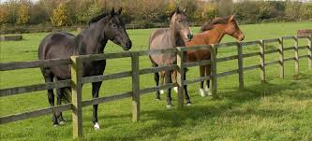
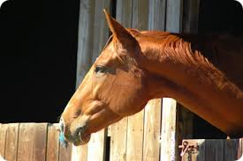

Thurleigh Equestrian Club
BHS STAGE 4 KNOWLEDGE
& CARE TRAINING

Thurleigh Equestrian Centre in partnership with Horses & Courses Limited are also delighted to offer budding students our new 14 week course is designed to assist you in preparing to take the BHS Stage 4 Horse Knowledge, Care and Management exam. The course is comprised of a 2 hour theory /practical training session, on Thursday evenings from 6.00pm to 8.00pm, course handouts and work pack materials for home study and guided research work. All teaching occurs in the clubhouse or indoor stable barn, so everyone remains dry!

Tea, coffee and cold drinks are provided and there is a changing room for anyone attending straight from work.

Course Dates: Thursday 7th August to 6th November 2014.

Course Costs:
For the 14 week course | £345.00*
Per weekly 2hr session | £30.00
It is possible to attend specific weekly sessions or to attend the full 14 week course.

Payment must be received 1 week before the first day of the course. If you wish to pay by credit card this can be done at www.horsesandcourses.co.uk.
*Price includes free membership to Thurleigh Equestrian Club.

Stage 4 Course Content

Week | Topic | Home Study / Research
1  (Unit 1.1)  (Unit 5.2) | - Intro to course & review of BHS requirements - handling horses etc.  - Working safely with horses, inc. methods of restraint  - Review range of regimes & how they affect behaviour. | - Variety of bits available  - Action & reasons

2  (Unit 1.1) | - Evaluate & fit a variety of bits for different disciplines.  - Select, fit & review tack for Dressage.  - Evaluate, select & fit leg protection – boots & bandages. | - Tack required for different disciplines –Rules, what is allowed & what is not allowed & why?
3  (Unit 1.1) | - Evaluate & demonstrate tack fitting for jumping, eventing & endurance – inc martingales.  - Bandaging; reasons & fitting a hock bandage. | - Musculature of the horse
4  (Unit 2.1) | - Review of muscles, tendons & ligaments.  - Common problems & injuries.  - Analysis of static conformation: | - Conformational strengths & weaknesses for different disciplines.
5  (Unit 2.2) | - Conformational problems in a variety of horses.  - Evaluating a variety of horse’s potential use & condition. | - Conformational faults & related problems.
6  (Unit 2.2) | - Analysis of static conformation – strengths & weaknesses.  - Dynamic Conformation -Trotting up & gait analysis. | - Fitness requirements for different disciplines
7  (Unit 3.2) | - Fittening Horses – Levels of fitness for different disciplines, types of programme. | - Functions of skeletal, digestive & integument systems.
8  (Unit 5.1) | - The physiological systems of the horse- function of skeletal, digestive, integument & how these relate to care. | - Function of the reproductive system- male & female
9  (Unit 5.1 & 5.2) | - The physiological systems of the horse- function of nervous system & reproductive systems | - Nutritional requirements & feed content of common feeds.

10  (Unit 3.2) | - Nutrition- Types of feed & nutritional values.  - Common dietary issues & dehydration | - Legislation for equine business
11  (Unit 4.1) | - Managing an Equine Business – Insurance, planning, customer care & legislation | - H&S requirements & staffing a yard
12  (Unit 4.3) | - How to manage equestrian facilities- care & maintenance of facilities, arenas & grassland  - How to manage a yard- part 1 - H&S & Staff | - Specific care requirements of breeding & youngstock.
13  (Unit 4.3) | - How to manage a yard - Horses & security.  - Review horse requirements at various stages of development including brood mare & youngstock | - Prep for mock exam.
14 | - Mock exam session & feedback

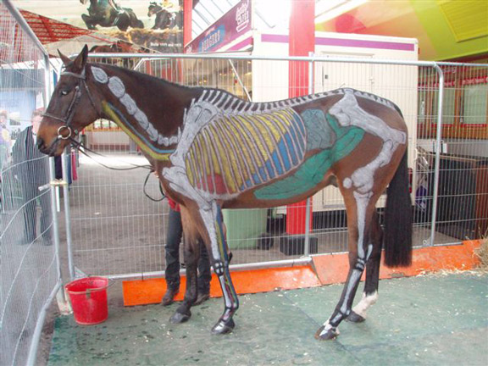
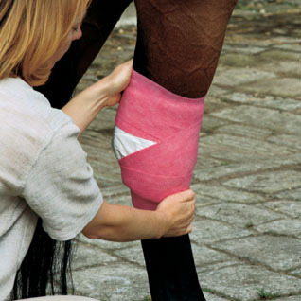

HORSE CARE & MANAGEMENT / BHS STAGE 4 BOOKING FORM

To book your place on any of our courses simply complete this booking form and e-mail it to us at office@thurleighequestriancentre or call 0845 6804528 if you would like to speak to us first.

ABOUT YOU:
Name of Student

Name and signature of Parent or Guardian (if under 18)
Home Address
Contact Number

Emergency Contact (if different to above)

Name of Emergency Contact

Contact e-mail Address

Allergies, or special medical information of relevance.

ABOUT YOUR CHOSEN COURSE:
Course Dates: | Level Of Course | Full week / Single Day  (F / S) | If Single Days (or booking specific BHS sessions), Please Indicate Days Of Attendance
28th July – 1st August | Introduction to Horse Care and Management Certificate (1)
4th – 9th August | Intermediate Horse Care and Management Certificate (1)
18th – 22nd August | Introduction to Horse Care and Management Certificate (2)
25th – 29th August | Intermediate Horse Care and Management Certificate (2)
7th Aug to 6th Nov 2014 | BHS Stage 4 KH&C Training Course

I hereby agree to abide by the Thurleigh Equestrian Centre Yard Guidelines (overleaf) and have read and accept the cancellation policy (If you under 18 you must have this signed by a parent or guardian).

Name: _______________ Signed: ___________________ Date:__________

Cancellation Policy - Any courses booked and cancelled within 36hrs of the start date will be charged for unless a replacement attendee can be found to take the space.

THURLEIGH EQUESTRIAN CENTRE YARD GUIDELINES

The rules of the yard are here to ensure that the yard remains a safe and enjoyable environment for all who use it, and Thurleigh Equestrian Centre appreciates your support in upholding them:

  - Please ensure that you listen to your instructor at all times and pay particular attention to any health and safety or fire warnings.
  - Please make sure you act in a responsible and sensible manner at all times during your courses/days on the yard.
  - Safe, suitable footwear must be worn when on the yard and around the horses. No flip flops or trainers are allowed.
  - Gloves and a hat must be worn when leading or handling horses on the yard. (these can be provided by the centre if needed)
  - Health and safety procedures set out by the Yard must be strictly adhered to. Smoking on the premises is strictly forbidden - anyone found smoking on the premises will be asked to leave immediately.
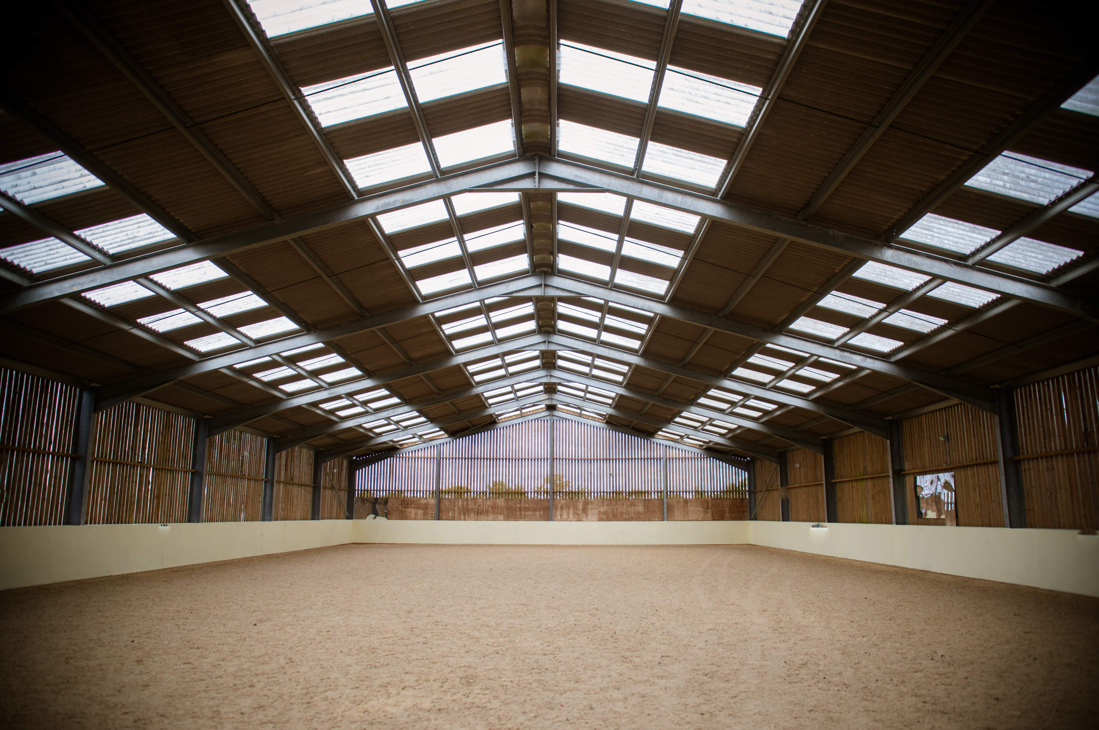
  - All students must not walk around the yard unattended. Particular care must be taken when near or on the muck heap and when walking around horses tied up on the yards or when walking through paddocks.
  - All droppings on the yard and schools/arenas must be removed after each use.
  - Please drive carefully and slowly around the yard and park in the designated spaces.
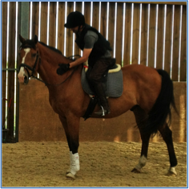
Thurleigh Equestrian Centre also offer riding lessons to riders aged 16 years old and over on our lovely 16.2 hh Oldenburg school master gelding Elgar and 16hh Irish Sports Horse Quinn.
Riding School @ Thurleigh

As all our lessons are one to one, we can cater to your specific requirements, for example, getting back into riding, building confidence, riding to improve your fitness or riding for fun.
What we offer:
- A friendly, welcoming environment in British Horse Society (BHS) Approved “Commended” Facilities
- Training provided by BHS qualified professional instructors & a choice of a western or English saddles
- Video/viewback facilities, indoor and outdoor arenas and small round pen arena for beginner lessons
- Use of the club-house, with tea and coffee and a changing room area

½ hour introductory lesson & rider assessment (required prior to booking regular lessons |  | £20
Individual Lessons | Per Lesson | If Booking a 4 Lesson Block
½ hour lesson in arena | £30.00 | £100.00
½ hour lunge lesson | £30.00 | £100.00
¾ hour lesson in arena | £38.00 | £130.00
1 hour lesson in arena | £44.00 | £160.00
½ video review of lesson with instructor | £15.00 | £75.00
½ field and track ride (weather permitting) | £28.00 | £90.00
1 hour stable management training (BHS syllabus) | £35.00 | £110.00

New Rider Introduction Package: We are offering a discount on the following package: ½ hour Intro lesson and Assessment, ½ hour arena lesson, ½ hour lesson with video review session (Full Price £95.00)
Special Offer Price £70.00 – valid until 30th August 2014.

For more inform visit our website at:
http://www.thurleighequestriancentre.co.uk (and click Riding School)

