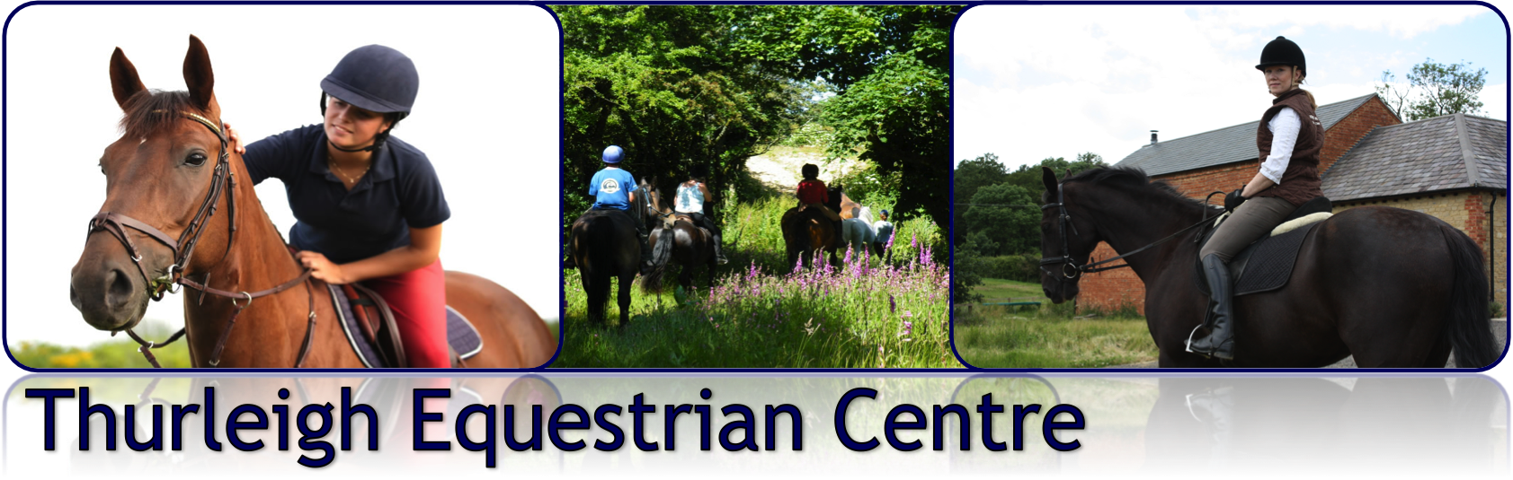

‘HAVE A GO’ AT SIDE SADDLE CLINIC
WITH GINNY OAKLEY.
Saturday 22nd February: From 10:00am
£45.00 per lesson (1 hr lesson in pairs)
Thurleigh Equestrian Centre – Indoor Arena
Ginny is a registered side-saddle instructor. She has competed at Advanced Level in Dressage, Show Jumping and Eventing, is the team manager of the British Side-Saddle display team and has successfully produced Working Hunters for HOYS and the Royal International Horse Show. This clinic caters for riders who already have their own side-saddle and wish to improve their skills, or those who have never tried it and would like to give it a go on their horse. A variety of side-saddles will be available to use on the day.

To book a place on this clinic simply complete this booking form and e-mail it to us at office@thurleighequestriancentre or call us on 01234 771882

Cancellation Policy
Any clinic sessions booked and cancelled within 36hrs of the clinic will be charged for unless a replacement rider can be found to take the space.
Booking Form
Rider Name

Have you ridden side saddle before?
Please provide brief details.
Rider height and weight- needed to help find you the most suitable saddle

Horse name & height - needed to help find you the most suitable saddle

Size of regular saddle
Preferred Time (10.00am – 4.00pm)
I hereby agree to abide by the Thurleigh Equestrian Centre Clinic Guidelines overleaf and have read the Side Saddle requirements and cancellation policy

Signed: _____________________________ Date: _________________
RIDING SIDE SADDLE GUIDELINES
Please could all attendees have the following in mind.
Most horses take to side-saddle very well. It is suggested that horses under 5 years are not presented nor horses that are known to buck (badly!) rear or bolt on a regular basis. Personally I would not wish to ride this type astride! Please use a bridle (bit) that your horse goes the best in. A martingale is fine to use if that is what your horse is used to.
Please indicate when booking the width and length of your normal saddle; your weight (ish!) and your height. This helps me chose a side-saddle to suit you and your horse.
Please warm up astride first and be on your astride saddle for the start of the session.(You are welcome to warm up in our outdoor arena and come into the indoor arena 5 min prior to the start of your session as the others are finishing)
Please use a dressage square which can be used under the side saddle.
Please wear normal riding attire and bring a long whip (fishing rods not required!)
Please do not wear Mountain Horse Boots. The emblem rubs holes in the side-saddle nor any chaps/gaiters with a lower emblem on the outside.
Please do not wear high dressage boots as your circulation may be cut off in your right leg!
(You may find that a short boot and sock on the right leg is easiest)
Please do not appear with mud-covered boots as your right leg is against the saddle and anything abrasive will damage it!
Please remove spurs prior to the side-saddle session if used for astride warm up.

Thank you!

THURLEIGH EQUESTRIAN CENTRE CLINIC GUIDELINES

- All equipment, vehicles and horses brought onto premises at Thurleigh Equestrian Centre are brought here at your own risk and the Centre take no responsibility for any damage or losses incurred when visiting the premises.
- Riders participating in TEC clinics do so at their own risk. The Centre and any persons acting on behalf of the Centre do not accept liability for any accident, loss, damage, illness or injury to ponies, horses, riders or spectators.
- Clinic fees must be paid in full on the day. The organiser has the right to refuse entries. Monies will not be refunded/carried forward except in exceptional circumstances. Cheques will not usually be banked until the event has taken place.
- All horses and ponies must be in a fit, sound and healthy condition to carry out the appropriate work. Anyone found to have an animal unfit or unsound may be asked to leave the event.
- Hard hats to standards: WN1384, PAS015:1998, ASTM F1163, BSEN14572:2005, or SEI. American standard SNELL E2001, ASTM 95, SNZ3838 1998 and correct footwear must be worn at all times when riding and leading. Skull caps must be worn with a silk. Body protectors are strongly advisable whilst jumping and are encouraged at all times when participating in horse riding activities
- It is the rider’s responsibility to ensure all tack and equipment is in a safe condition and suitable for the purpose it is intended for.
- Any rider who conducts him/herself in a manner which is regarded as unacceptable by the Centre will be required to leave the clinic immediately & may be denied admission to future Centre events.
- Thurleigh Equestrian Centre is a no-smoking site. Anyone found smoking anywhere on the premises will be asked to leave immediately.
- The safety of horse and rider are of paramount importance. Any member of the Centre may take any action deemed necessary in the interests of safety during any clinic or activity.
- Horses and ponies must not be left tied up unattended.
- No excessive use of whips will be tolerated.
- Please park with consideration and remove any horse droppings.
- NO riding or grazing on the grass areas please.
- Dogs are welcome on the yard, but must be kept on a lead at all times. The Yard reserves the right to ask for any dog deemed to be causing a nuisance to be removed. All dog mess must be cleared up immediately.

