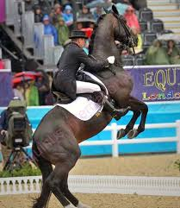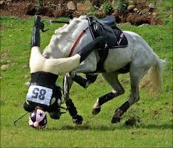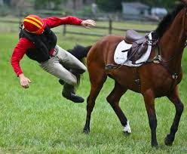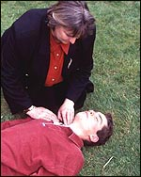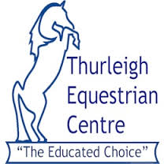 

**ONE-DAY EMERGENCY FIRST AID COURSE FOR HORSE RIDERS (QCF Level 2 Qualification) - Monday 13th October (£45.00 per person) from 9.30am**

This course is run by Medi-K and will give a complete overview of first aid procedures. It is specifically designed for those who are involved in horse riding activities, including events, leisure and recreation.

All participants will receive training by an experienced instructor and horse rider.  
On successful completion of this course all participants receive a certificated and nationally recognised qualification in First Aid.

This course consists of 7 hours of both theoretical and practical activities.

A range of subjects is covered including:-

Responsibilities and reporting, Resuscitation, Fainting, Assessment of the situation, Choking, Hygiene, Bleeding control, Shock, Minor burns and scalds, Riding hat and body protector removal, Recovery Position, Foreign Objects, Seizures, and Legalities.

We have **10 spaces available**, so book now to avoid disappointment!

To find out more, visit [www.thurleighequestriancentre.co.uk/events](http://www.thurleighequestriancentre.co.uk/events) or call 01234 771882

To book your place simply complete the booking form on the next page or call 01234 771882 if you would like to speak to us first

1 Day First Aid Courses

@ Thurleigh Equestrian Centre

|  |  |
| --- | --- |
| Name |  |
| Contact Number |  |
| E-mail Address |  |
| Allergies or Special Medical Information of Relevance |  |

1 Day First Aid Course

Booking Form

|  |  |  |  |  |
| --- | --- | --- | --- | --- |
| Course Details | Date(s) | Cost  (per person) | | Tick Your Choice |
| ONE-DAY EMERGENCY FIRST AID COURSE FOR HORSE RIDERS (QCF Level 2 Qualification) – 9.30 am start | 13th October 2014 | £45* | |  |
|  |  |  |  | |
| * To book your place, please send/enclose a cheque for 50% of the course fee, made payable to “**Horses and Courses Limited”**. The remaining fee must be paid on the first day of your course. | | | | |

Return this completed form to Thurleigh Equestrian Centre, Redgate Cottage, Mill Road, Thurleigh, Beds, MK44 2DP or e-mail to office@thurleighequestriancentre.co.uk

Name: _______________ Signed: ___________________ Date: __________

**Cancellation Policy - Any courses booked and cancelled within 7 days of the start date will be charged for unless a replacement attendee can be found to take the space.**