NOVEMBER & DECEMBER EVENTS
AT THURLEIGH EQUESTRIAN CENTRE

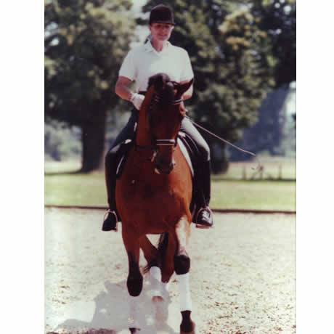
SAT 15th NOV & SAT 6th DEC:
CHAR LASSETTER DRESSAGE CLINIC.

From 8.00am: £58.00 per individual 45min lesson.
In indoor arena.
Char is an international dressage rider and trainer who has helped numerous riders up through the level in both dressage and eventing. Her experience at competing at Grand Prix give her clients a practical and workable insight on how to improve performance.

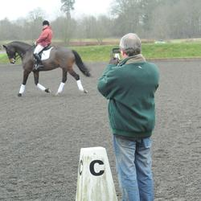
SAT 22nd NOV & SAT 20th DEC
DRESSAGE ANYWHERE TEST RIDING AND FILMNG DAYS

From 1.30pm . Entry fees range from £12.50 to £16.00 depending on class

Warm up and test ridden in 20 x 40m Indoor Arena

November tests:
BD Walk and Trot test – Intro B (2009) £12.50 entry fee
Pony Club Dressage Test C Level (2012) £12.50 entry fee
BD Preliminary 1 (2006) £14.50 entry fee
BD Novice 24 (2010) £14.50 entry fee
BD Elementary 45 (2010) £16.50 entry fee
.
To enter a test or book a place on a clinic simply e-mail us at office@thurleighequestriancentre.co.uk or call us on 01234 771882

Cancellation Policy
Any sessions booked and cancelled within 36hrs of the event will be charged for unless a replacement rider can be found to take the space.

DRESSAGE ANYWHERE’ WINTER COMPETITIONS
SAT 22nd NOV & SAT 20th DEC: TEST RIDING & FILMING

From 1.30pm : Entry fees from £12.50 to 16.50 per class.

Do you want to compete but do not want to dress up, travel far or deal with a busy warm up arena? The answer is to ride a ‘Dressage Anywhere’ test here at Thurleigh Equestrian Centre.

You can wear your usual riding gear, warm up alone, have a practice run through the test and then ride test in our indoor arena while we film it and enter it into the Dressage Anywhere May dressage competition.

Your test is judged by an affiliated dressage list 1 or 2 judge and you receive a completed test sheet with judges comments and score, just as if you are competing in a live class, you will even win prize money or vouchers if you come in 1st to 3rd.

For our riding school clients, we can also provide a horse for you to ride the test on if you would like to have a go!

November tests: | December Tests | Entry Fee
BD Walk and Trot test – Intro B (2009) | Intro A (2008) | £12.50
BD Preliminary 1 (2006 | Preliminary 7 (2002) | £14.50
BD Novice 24 (2010) | Novice 23 (2012) | £14.50
BD Elementary 45 (2010) | Elementary 49 (2009) | £16.50
Pony Club Dressage Test C Level (2012)** | Pony Club Dressage Test C Level (2012)** | £13.50

Any rider is free to enter a Dressage Anywhere competition and does not need to be a member of the relevant body but juniors of 16 years of age and under must have parental permission

** For Pony Club Tests you must be a Pony Club member or under 26 years of age..
If you are a British Dressage Associate Member and are taking part in Introductory, Prelim, Novice and Elementary classes you also have the opportunity to achieve two scores of 62% or above to qualify for the Championship Show.
To receive an entry form simply e-mail us at office@thurleighequestriancentre.co.uk or call us on 01234 771882

