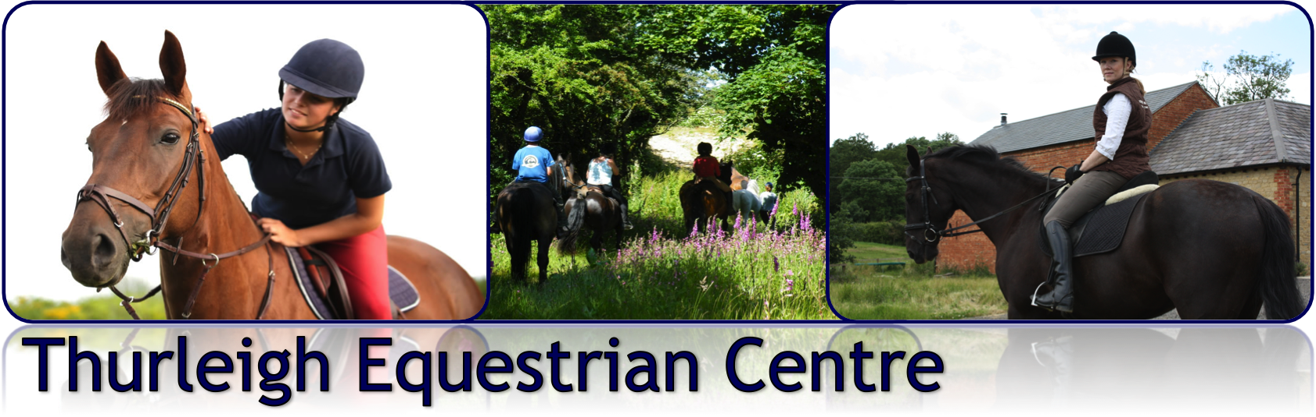
DRESSAGE CLINIC WITH MATT COX

Saturday 9th November 2013
From 10:30am–
£40.00 per lesson
Thurleigh Equestrian Centre – Indoor Arena

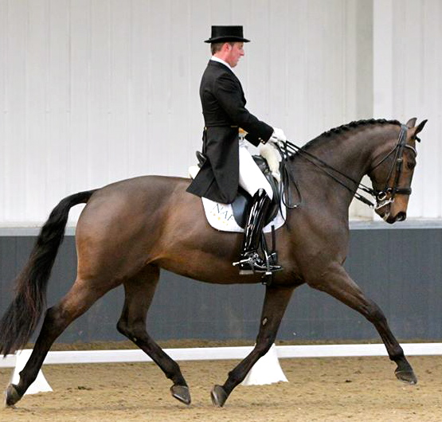
Matt Cox is an accomplished dressage rider and a British Dressage Eastern trainer. Matt shares his expertise and love of horses with clients who want to get the very best out of their equine partners at any level. He likes to help the rider develop the all-important “Feel” for the correct way of going, drawing on a wealth of knowledge passed on from riders such as Carl Hester, Spencer Wilson, Mark Ruddock and Isobel Wessels.

To book your clinic simply complete this booking form and e-mail it to us at office@thurleighequestriancentre or call 0845 6804528.

Cancellation Policy

Any clinic sessions booked and cancelled within 36hrs will be charged for unless a replacement rider can be found to take the space.

Booking Form

Rider Name & Horse | Preferred Time (10.30am – 4.15pm)

I hereby agree to abide by the Thurleigh Equestrian Centre Clinic Guidelines overleaf and have read the cancellation policy

Signed: _____________________________ Date: _________________
THURLEIGH EQUESTRIAN CENTRE CLINIC GUIDELINES

- All equipment, vehicles and horses brought onto premises at Thurleigh Equestrian Centre are brought here at your own risk and the Centre or Club take no responsibility for any damage or losses incurred when visiting the premises.
- Riders participating in TEC clinics do so at their own risk. The Centre and any persons acting on behalf of the Centre do not accept liability for any accident, loss, damage, illness or injury to ponies, horses, riders or spectators.
- Clinic fees must be paid in full on the day. The organiser has the right to refuse entries. Monies will not be refunded/carried forward except in exceptional circumstances. Cheques will not usually be banked until the event has taken place.
- All horses and ponies must be in a fit, sound and healthy condition to carry out the appropriate work. Anyone found to have an animal unfit or unsound may be asked to leave the event.
- Hard hats to standards: WN1384, PAS015:1998, ASTM F1163, BSEN14572:2005, or SEI. American standard SNELL E2001, ASTM 95, SNZ3838 1998 and correct footwear must be worn at all times when riding and leading. Skull caps must be worn with a silk. Body protectors are strongly advisable whilst jumping and are encouraged at all times when participating in horse riding activities
- It is the rider’s responsibility to ensure all tack and equipment is in a safe condition and suitable for the purpose it is intended for.
- Any rider who conducts him/herself in a manner which is regarded as unacceptable by the Centre will be required to leave the clinic immediately & may be denied admission to future Centre events.
- Thurleigh Equestrian Centre is a no-smoking site. Anyone found smoking anywhere on the premises will be asked to leave immediately.
- The safety of horse and rider are of paramount importance. Any member of the Centre may take any action deemed necessary in the interests of safety during any clinic or activity.
- Horses and ponies must not be left tied up unattended.
- No excessive use of whips will be tolerated.
- Please park with consideration and remove any horse droppings.
- NO riding or grazing on the grass areas please.
- Dogs are welcome on the yard, but must be kept on a lead at all times. The Yard reserves the right to ask for any dog deemed to be causing a nuisance to be removed. All dog mess must be cleared up immediately.

