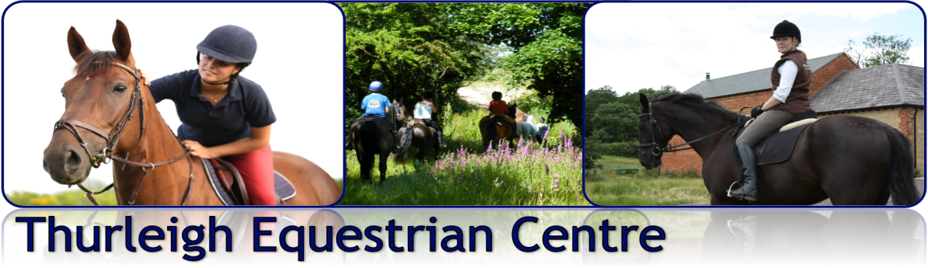
in association with

ANNIVERSARY CHARITY SHOW: 22nd Sept 2013
Raising Money for Macmillan Cancer Charity

10.00am - CLASS 1: BEST DRESSED DRESSAGE - Indoor Arena
Pick your test from: Intro A (2008); Prelim 13 ( 2006) or Novice 25 (2005)
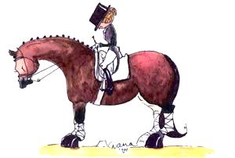
Rosettes to 5th place , prizes to 3rd place

Prizes awarded for: Highest score, best turned out & best effort
Points will also be awarded to the top three riders to go towards the final TEC team challenge

Entry fee £5.00 including annual membership to Thurleigh Equestrian Club

11.30 – 11.45 – Opportunity to walk the course

11.45am- CLASS 2: SHOW JUMP ACCUMULATOR CLASS
Kindly sponsored by Chris and Will Moore

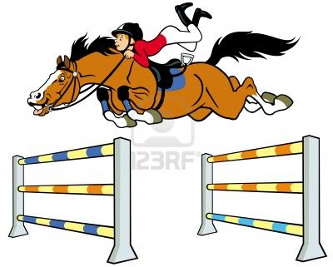
Each fence has a different value - the rider who gets the highest score wins.

Rosettes to 5th Place, prizes to 3rd place

Prizes awarded for; Highest score, Most stylish round, Best effort. Points will also be awarded to top three riders to go towards the final TEC team challenge

Entry fee £5.00 – including annual membership to Thurleigh Equestrian Club

12.45 – 1.15pm – FUN JUMPING OPPORTUNITY!
For those that just want to have a go around the course.

Entry: £1.00 per round.
1.30PM – CLASS 3: SHOW OFF YOUR HORSE OR PONY CLASS
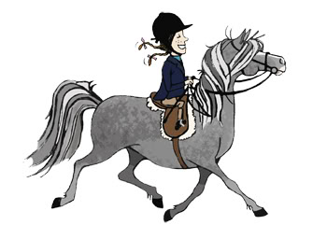
This class combines turn out with handy horse / pony skills. You will need to show off your horse or pony’s best features, obedience, manoeuvrability and general behaviour. THIS CLASS CAN BE DONE IN HAND OR UNDER STADDLE

Rosettes to 5th place and prizes to 3rd place.

Prizes awarded for; Best turned out, Most handy horse & rider & Best effort. Points will also be awarded to the top three riders to go towards the final TEC team challenge

Entry fee £5.00 – including annual membership to Thurleigh Equestrian Club

2.45PM – “FOXES v HOUNDS” TEAM CHALLENGE;
As each competitor will have also been earning points for their team (allocated on the day, a Fox or a Hound) this final challenge will be a chance for partners, husbands, wives (and anyone who wants to) to have a go and accumulate points for their team! This event will be a combination of horse and on foot activities to see which team come away with the highest points & win the overall team prize. Further details on the day!

3.30pm PRIZE GIVING – by Judges for all classes

4.00pm – END OF SHOW BBQ
Please and let us know if you would like to join us for the BBQ and if you have any specific dietary requirements on the entry form below.

ENTRY FORM: Thurleigh Equestrian Club Anniversary Charity Show (22nd Sept)

RIDER | HORSE | CLASS (please state test for class 1) | FEE ENCLOSED
 |  | TOTAL ENCLOSED £

Please make cheques payable to ‘Horses & Courses Ltd’

Preferred contact details to confirm entry: ________________________________________

- I do/do not want to join the Thurleigh Equestrian Club (delete as applicable).
- I would like ____________ tickets for the BBQ.

ANY SPECIFIC DIETRY REQUIREMENTS? ___________________________________________
I agree to abide by the Thurleigh Equestrian Club Show Rules and Regulations overleaf

Signed: ______________________________________________
THURLEIGH EQUESTRIAN CLUB (TEC) SHOW RULES & REGULATIONS

- All equipment, vehicles and horses brought onto premises at Thurleigh Equestrian Centre are brought here at your own risk and the Centre or Club take no responsibility for any damage or losses incurred when visiting the premises.
- Riders participating in TEC activities do so at their own risk. The Club and any persons acting on behalf of the Club do not accept liability for any accident, loss, damage, illness or injury to ponies, horses, riders or spectators.
- The Judge’s or Committee’s decision is final. If you have any issues/complaints/problems please speak to a member of the Committee or put it in writing and forward to the Club Chairman. The committee, whose decision is final, will consider the grievance at the next committee meeting.
- Entries to an event must be paid in full by the closing date. The organiser has the right to refuse entries, cancel or amend classes or groups. Monies will not be refunded/carried forward except in exceptional circumstances. Cheques will not usually be banked until the event has taken place.
- All horses and ponies must be 4 years old or over for all ridden events and in a fit, sound and healthy condition to carry out the appropriate work. Anyone found to have an animal unfit or unsound may be asked to leave the event.
- No stallions may take part in any of the events and no colts over the age of 1
- Where events are for members only, the rider must be a fully paid up member for insurance purposes.
- All members must be 12 years of age in the current year or on a family membership.
- Hard hats to standards: WN1384, PAS015:1998, ASTM F1163, BSEN14572:2005, or SEI. American standard SNELL E2001, ASTM 95, SNZ3838 1998 and correct footwear must be worn at all times when riding and leading. Skull caps must be worn with a silk. Body protectors are strongly advisable whilst jumping and are encouraged at all times when participating in horse riding activities
- It is the rider’s responsibility to ensure all tack and equipment is in a safe condition and suitable for the purpose it is intended for.
- Any competitor who conducts him/herself in a manner which is regarded as unacceptable by the committee will be required to leave the event immediately & may be denied membership and/or admission to future Riding Club events.
- The safety of horse and rider are of paramount importance. Any member of the Committee may take any action deemed necessary in the interests of safety during any Club activity.
- For Dressage show jackets and light coloured jodhpurs are encouraged but are not essential as long as you look smart. Please do not let the lack of a jacket etc put you off.
- Horses and ponies must not be left tied up unattended.
- No excessive use of whips will be tolerated.
- Please park with consideration and remove any horse droppings.
- NO riding or grazing on the grass areas please.
- Dogs are welcome on the yard, but must be kept on a lead at all times. The Yard reserves the right to ask for any dog deemed to be causing a nuisance to be removed. All dog mess must be cleared up immediately.

